Rosemary-Pepper Beef Rib Roast with Porcini Jus
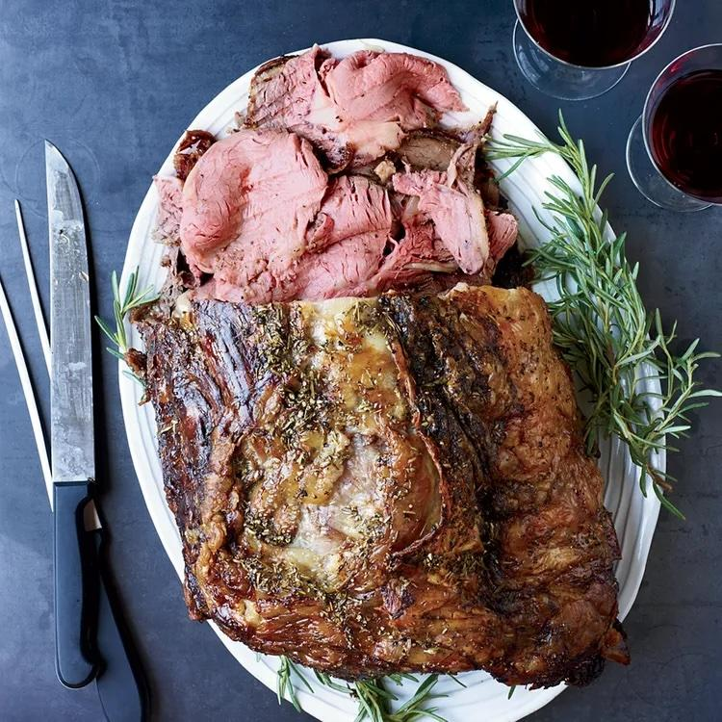

Active Time: 30 mins
Total Time: 4 hrs
Yield: 12 to 14

Ingredients
- 1/4 cup coarsely chopped fresh rosemary
- 3 tablespoons fresh coarsely ground black pepper, plus more for seasoning
- 3 tablespoons vegetable oil
- One 6-rib standing beef rib roast (14 to 15 pounds), 1/2-inch fat cap left on the meat
- Salt
- 3 tablespoons unsalted butter
- 1 medium shallot, very finely chopped
- 2 large garlic cloves, thinly sliced
- 1/4 cup dry red wine
- 1 quart beef stock or broth
- 1/4 cup sherry vinegar
- 4 thyme sprigs
- 1 ounce dried porcini (1 cup), ground to a powder in a spice grinder or blender

Directions
- In a small bowl, combine the rosemary with the 3 tablespoons of black pepper and the vegetable oil and rub all over the roast. Cover and refrigerate overnight.
- Put a large roasting pan in the middle of the oven and preheat to 375°. Let the rib roast stand at room temperature for 30 minutes.
- Season the roast with salt and put it in the hot roasting pan, fat side down. Roast for 30 minutes. Turn the roast over and cook at 350° for about 3 hours, rotating the pan 2 or 3 times. The roast is done when an instant-read thermometer inserted in the thickest part of the meat registers 130° for medium-rare. Transfer the roast to a carving board to rest for at least 20 minutes.
- Meanwhile, in a saucepan, melt the butter. Add the shallot and garlic and cook over moderate heat until lightly browned, 5 minutes. Add the wine and boil for 2 minutes. Add the stock, vinegar and thyme and bring to a boil. Simmer over moderate heat until reduced to 2 1/2 cups, about 20 minutes. Strain the sauce and return it to the saucepan. Whisk in the porcini powder and simmer for 1 minute. Cover, remove from the heat and let stand for 5 minutes. Season with salt and pepper. Carve the roast and serve with the porcini jus.

Make Ahead
The porcini jus can be refrigerated overnight. Reheat gently.

Roast Leg of Lamb with Rosemary and Lavender

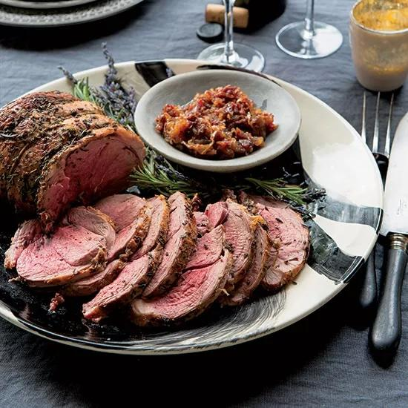

Active Time: 35 mins
Total Time: 2 hrs
Servings: 6 to 8 servings

Ingredients
- 1/4 cup plus 2 tablespoons extra-virgin olive oil
- 1/4 cup minced rosemary
- 3 tablespoons minced fresh lavender leaves (see note)
- 4 garlic cloves, grated
- 1 (3 1/2-pound) boneless leg of lamb
- Kosher salt
- Freshly ground black pepper
- 6 medium shallots, thinly sliced
- 1/2 cup pitted Medjool dates, thinly sliced
- 1 teaspoon honey
- 1/4 cup apple cider vinegar

Directions
- Preheat the oven to 450°F. In a small bowl, whisk 1/4 cup of the olive oil with the rosemary, lavender, and garlic. Season the lamb all over with salt and pepper. Rub half of the herb oil all over the inside of the lamb, then roll up the meat and tie with kitchen string to form a neat roast. Spread the remaining herb oil all over the roast and set it on a rimmed baking sheet.
- Roast the lamb for about 15 minutes, until just starting to brown. Reduce the oven temperature to 375°F and roast the lamb for about 1 hour longer, until an instant-read thermometer inserted in the thickest part registers 130°F for rare meat. Transfer the lamb to a carving board and let rest for 30 minutes.
- Meanwhile, in a medium saucepan, heat the remaining 2 tablespoons of olive oil until it shimmers. Add the shallots, dates, honey and a pinch of salt and cook over moderate heat, stirring occasionally, until the shallots are softened, about 7 minutes. Add the vinegar and cook, stirring occasionally, until most of the liquid has evaporated and the jam is thick, 3 to 5 minutes; season with salt and let cool.
- Untie the lamb roast and slice the meat against the grain. Serve with the shallot-date jam.

Make ahead
The shallot-date jam can be refrigerated for up to 5 days. Bring to room temperature before serving with the roast leg of lamb.

Rosemary-Parmesan Popcorn
Total TimePrep/Total Time: 20 min.
Yield 10 cups

Ingredients
- 1/4 cup fresh rosemary leaves
- 10 cups popped popcorn
- 1/4 cup butter, melted
- 3 tablespoons grated Parmesan cheese
- 1/2 teaspoon salt
- 1/4 teaspoon coarsely ground pepper

Directions
- Place rosemary on a baking sheet. Bake at 300° for 10 minutes or until crisp. Finely chop rosemary or crush using a mortar and pestle; set aside.
- Place popcorn in a large bowl; drizzle with butter. Sprinkle with cheese, salt, pepper and rosemary; toss to coat.

Nutrition Facts
1 cup: 113 calories, 10g fat (4g saturated fat), 13mg cholesterol, 290 mg sodium, 5g carbohydrate (0 sugars, 1g fiber), 1g protein.

Lemon-Rosemary Sorbet



Yield: 3 cups

Ingredients
- 2 cups water
- 1 cup sugar
- 2 rosemary sprigs
- ½ cup fresh lemon juice

Directions
- In a saucepan, bring the water, sugar and rosemary to a boil. Cover and simmer over low heat for 5 minutes. Discard the rosemary and let the syrup cool to room temperature. Add the lemon juice and refrigerate until chilled. Transfer to an ice-cream maker and freeze according to the manufacturer's directions.

Make Ahead
The sorbet can be kept in the freezer for up to 2 days.

